Practical - 6
Practical Title: Rendering External JSON Data using Fetch API, Search and Filter

Display event lists, student profiles, notices, or FAQs from external JSON files using Fetch API. Implement dynamic rendering, search, filter, sorting, and pagination.

Theory
1. How is JSON fetched, parsed, and rendered?
- Fetch: fetch() retrieves the JSON file from the specified path.
- Parse: response.json() converts the JSON data into JavaScript objects.
- Process: The data is stored and processed using JavaScript.
- Render: JavaScript dynamically creates HTML elements and displays the data on the webpage.
- Update: The displayed content changes based on search, filter, sorting, and pagination.
2. Which array methods are used for search, filter, sort, and pagination?
- Search: filter()
- Filter: filter()
- Sort: sort()
- Pagination: slice()
3. How are loading and error states handled?
- Loading State: A loading message is displayed while the JSON data is being fetched.
- Error Handling: If the JSON file cannot be loaded, an error message is displayed to the user.
- Fetch API: .catch() is used to handle fetching errors.
- User Feedback: The user is informed whether the data is loading, successfully loaded, or failed to load.
4. How is modularity maintained in JavaScript files?
- By dividing the code into small, independent functions.
- By using separate files for different functionalities.
- By using import and export to share functions and variables between modules.
- By avoiding code duplication through reusable functions.
- By keeping HTML, CSS, and JavaScript separate for better code organization.
- By making the code easier to maintain, test, and debug.

Implementation/ Output/Result

My learning codes: https://drive.google.com/file/d/1CPP3uUq3gdKZxC3pFB7iheZVU7FCImSx/view?usp=drive_link

Evidence of Work (Screenshots)
JSON files:
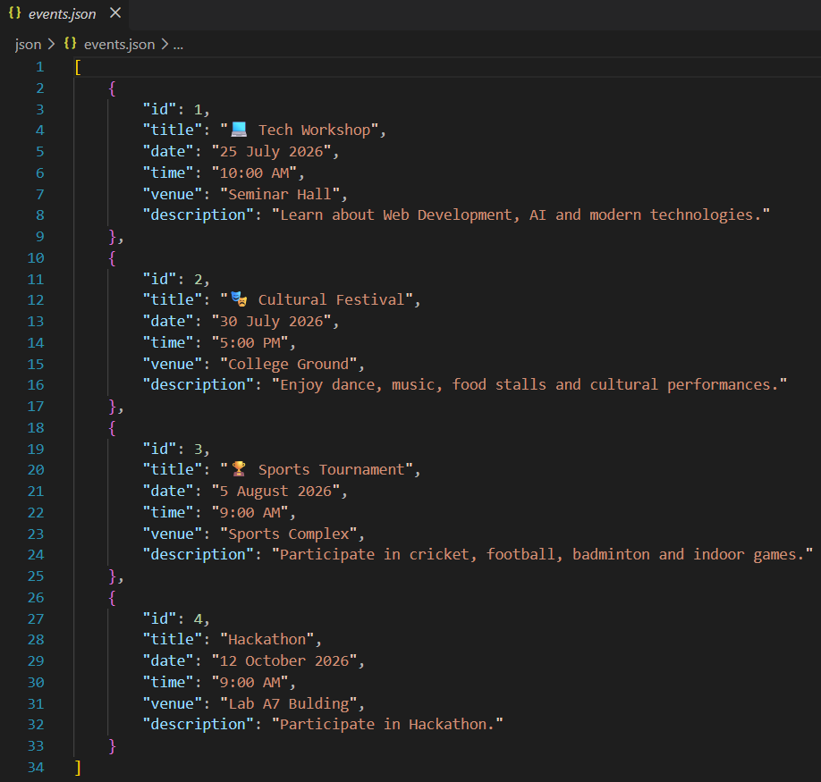
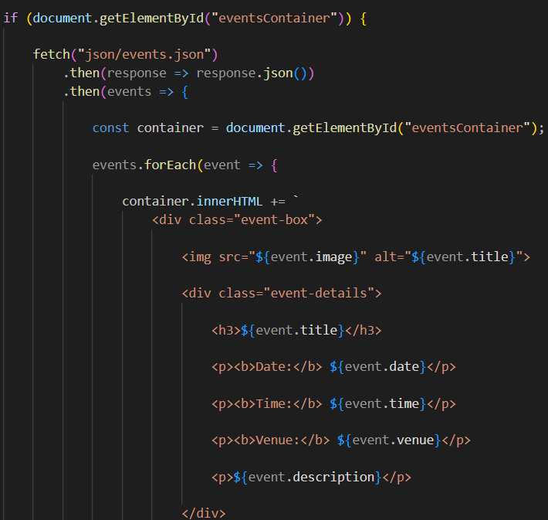
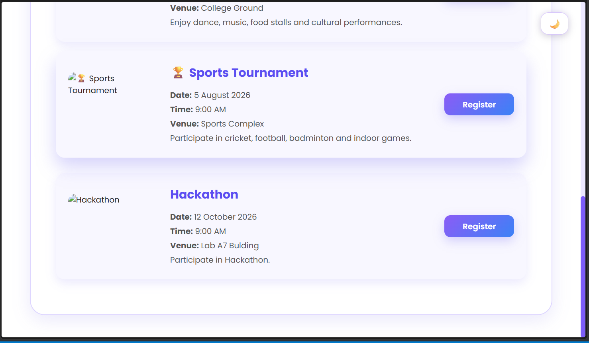
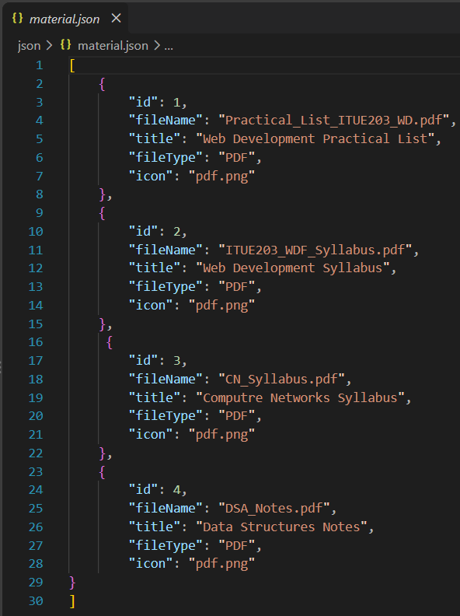
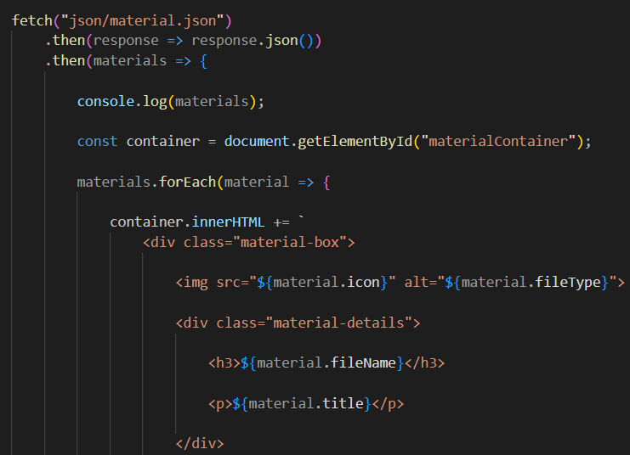
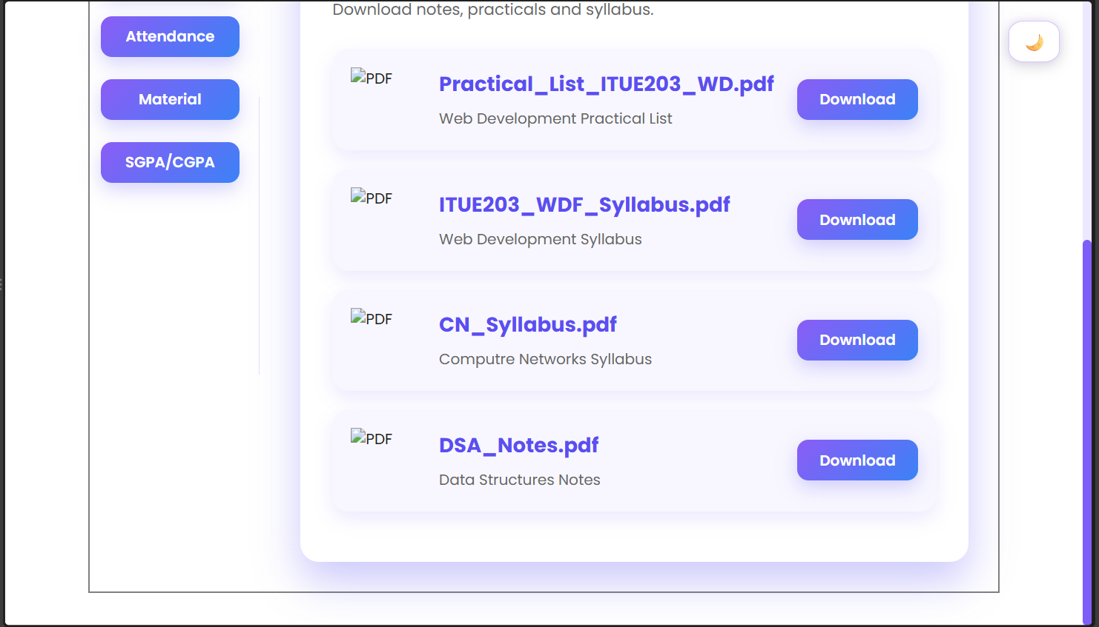
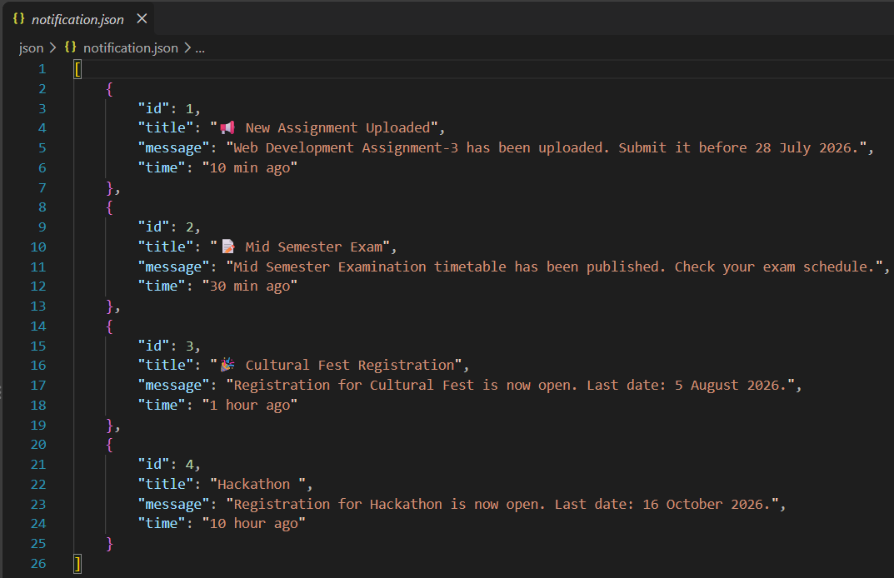
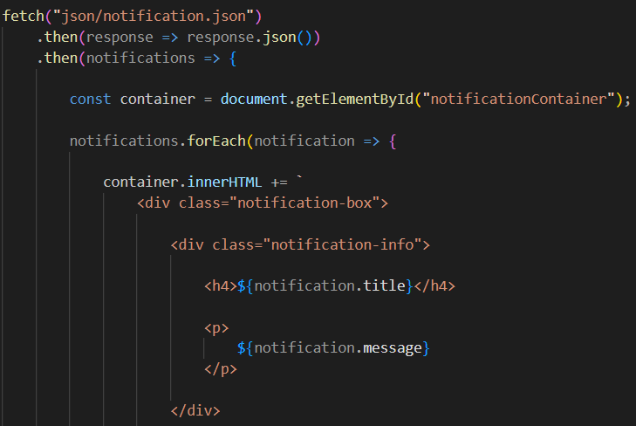
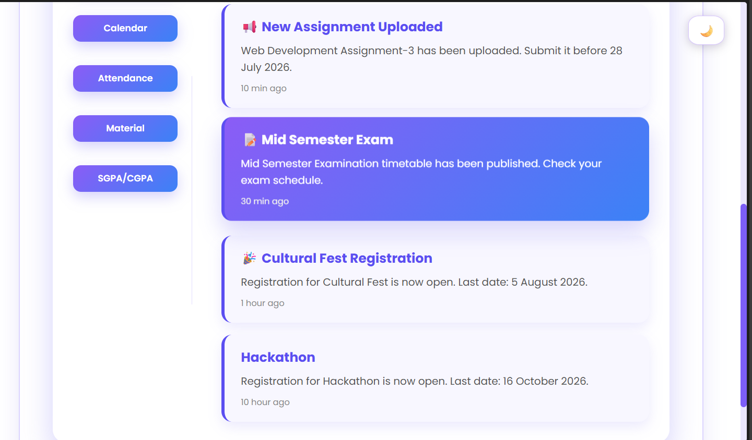
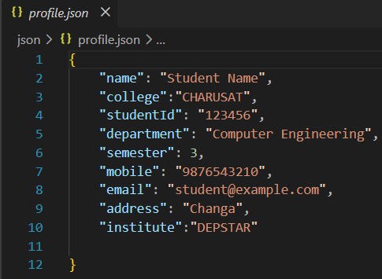
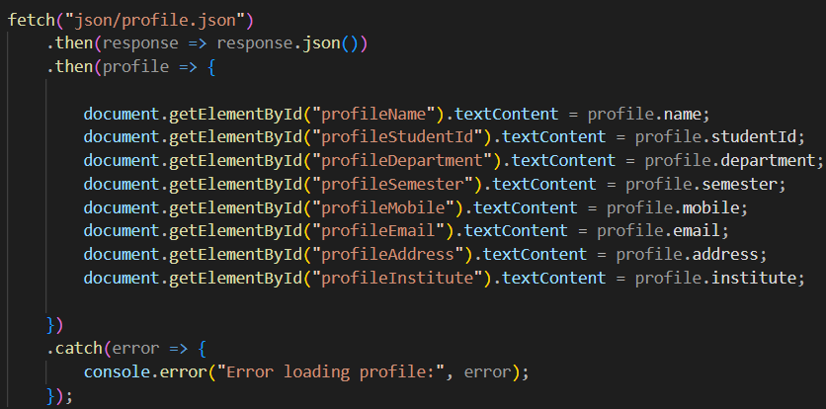
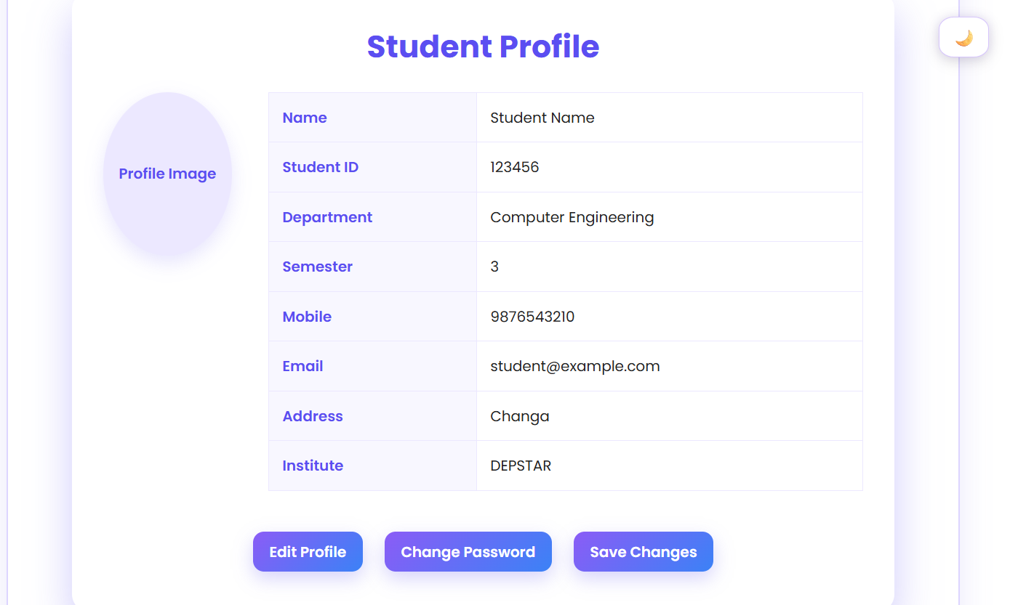
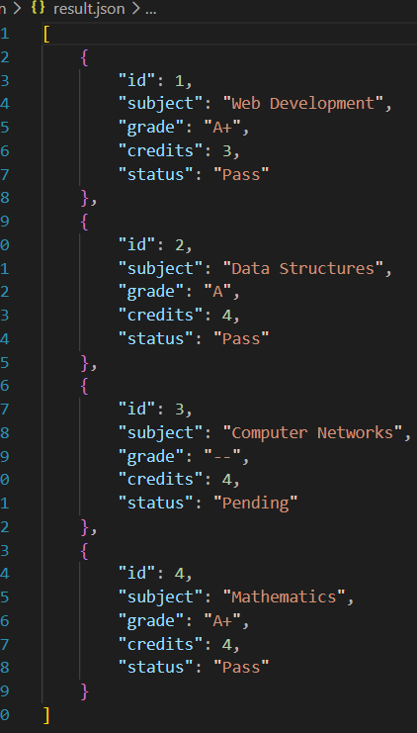
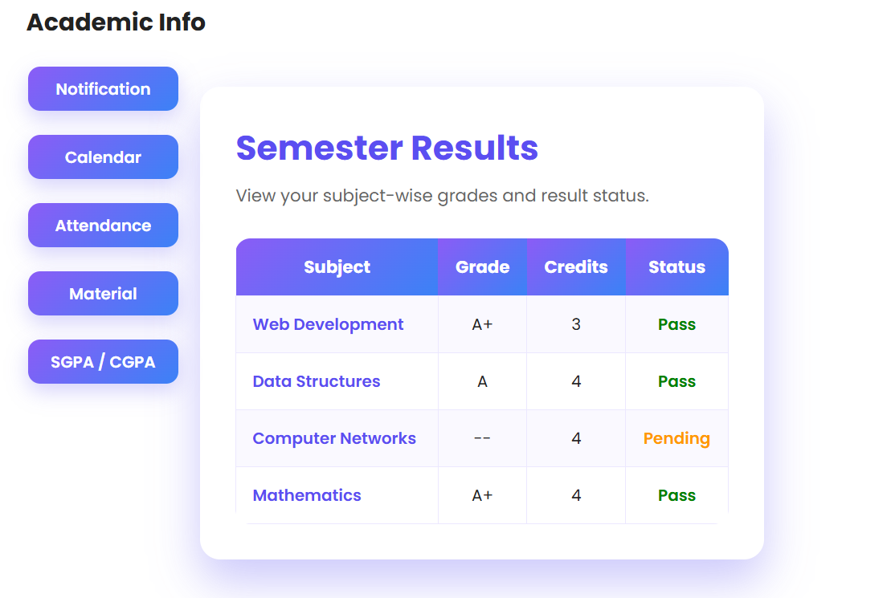

GitHub Repository Link:
Khushi-Thakor2007/Student-Hub-Portal

Challenges Faced:
I faced problem with connecting the JSON file.

Learning Outcomes:

I learned basic JSON in this practical.

Faculty Remarks:

